Functional ingredients and consumer products continued to rise, and recent years saw accelerated growth among key ingredients. This creates opportunities for players in the field of nutrition in the health market to create innovative offerings with scientifically substantiated ingredients. As our understanding of antioxidants increased over time, scientists have also looked toward nature to find dietary sources which have traditionally provided support for human health owing to their antioxidant and anti-inflammatory activity. Many consumers are not aware of the science behind these ingredients or believe that many products on the market feature claims that seem too good to be true with a lack of scientific research to back them. In our article we will try to explain main features of TAXIFOLIN rich Extract proved by scientific research during decades.

"Etalon Cosmetics" (Russian Federation) as a company grounded in science has dedicated years of research to learning about the science behind TAXIFOLIN to fully understand the extent of its benefits.

"Etalon Cosmetics" delivers non-GMO TAXIFOLIN in the same colorful packages as nature: the purples, blues and reds that are the polyphenol components of fruits and berries where TAXIFOLIN is found. Nature delivers TAXIFOLIN to us in the colorful packages of fruits and berries. The deep purples, blues and reds comprise the polyphenol components of these fruits: anthocyanins, proanthocyanidins, bioflavonoids and polyphenol (dihydroflavonol) – TAXIFOLIN which is responsible for the red color in fruits and berries according biosynthesis.

The main raw material used to obtain Taxifolin is the butt of larch. Generally, TAXIFOLIN-RICH EXTRACT is recovered from saw logs of larch tree by chipping or grinding the wood after debarking and extracting in thermo-vacuum system of using energy to heat solvent the purified water – ethanol solution (<420C) in contact with wood particles in order to extract Taxifolin from the wood particles.



TAXIFOLIN is a safe, natural molecule with strong antioxidant and anti-inflammatory activity, continued displaying a variety of health-promoting properties and modulating diverse biological functions. TAXIFOLN has opportunities to reach consumers in search of general health and wellness protection, as well as those who opt for targeted solutions, looking for the ultimate wellness solutions. In that context, consumers may find it important to consume TAXIFOLIN as part of their ‘multi’ intake, and especially when it comes to issues like healthy aging, prevention of metabolic syndrome, sports recovery, cognitive health, healthy immune system, or beauty.

TAXIFOLIN has been shown to benefit circulation, joints, eyes, respiratory health and more, making it a smart choice for consumers looking for an ingredient that offers “all-around” benefits. With more than 60 years of scientific research behind it, showing its benefits, this ingredient has the science to back its benefits.

Fundamentally, antioxidants are generally not well understood among consumers. Certainly less than condition-specific ingredients and formulations. They have a general idea that they are ‘good for them’ but beyond that there are a range of perceptions—not always well informed—about their value. Consumers don’t fully recognize the differences between various antioxidants and their mechanisms of action.

They also don’t understand that many antioxidants, under certain conditions, can become pro-oxidants and have a deleterious effect on our bodies by causing additional oxidation. Consumers have to be educated that, if they wisely decide to supplement with an antioxidant, they need to take one that has no pro-oxidant effects like natural TAXIFOLIN.

TAXIFOLIN is a power to seek ways to increase your overall well-being.

TAXIFOLIN - true antioxidant - ORAC value.

Muddying the waters for consumers, the ORAC (oxygen radical absorbance capacity) assay is an important case study. ORAC was initially employed as a tool to guide researchers as they ranked or selected different foods or ingredients for further study based on total antioxidant capacity.

Generation of free radicals (reactive oxygen species and reactive nitrogen species) occurs during normal metabolism and are also used in the immune system to fight off infections or invaders. Free radicals are byproducts of the body’s normal metabolic processes. They are unstable because they have an uneven number of electrons. This makes it easy for free radicals to react with other molecules (to form long chain chemical reactions)—a process known as oxidation. For this reason, free radicals are also called reactive oxygen species. Once again, oxidation is a normal and necessary process. However, if left unchecked, these free radicals can cause cellular damage at the structural and functional levels.

|  |  |
| --- | --- |
| **TAXIFOLIN-RICH EXTRACT 92% purity assay ( manufacture "Etalon Cosmetics", Russian Federation)** **ORAC Using Multiple Radicals (ORAC-FN): New Horizons in Total Antioxidant Capacity Measurement.** | |
| **ORACFN Test by Brunswick Laboratories, INC (USA)** | |
| **Antioxidant Power Result** ( **μmole TE/gram )** | |
| Against Peroxyl Radicals | 23 075 |
| Against Hydroxyl Radicals | **32 873** |
| Against Peroxynitrite | 975 |
| Against Super Oxide Anion | 7 228 |
| Against Singlet Oxygen | 2 795 |
| **Total ORACFN** | **66 946** |

*TAXIFOLIN has the highest ORAC value among botanical antioxidants. TE - Trolox® (a water-soluble analogue of vitamin E) as a standard by which all other antioxidant compounds are compared.*

The human body has mechanisms in place to stabilize or neutralize free radicals, called antioxidants. There are endogenous antioxidants produced by the cells themselves, and the body also relies on exogenous antioxidants present mainly in our diets, such vitamin C, vitamin E, etc.

Oxidative stress is an imbalance between the levels of free radicals produced by the body and the amount of antioxidants available to neutralize these free radicals. Under situations of oxidative stress, free radicals damage the cell’s membranes, DNA, proteins, etc. Collectively, these increase the body’s inflammatory response. Normal physiological and biochemical processes are subsequently compromised making one more vulnerable to disease conditions. Free radicals are “little marauders,” these electron-deficient atoms seek to steal electrons from others, making them highly unstable as they cruise the body in their electron quest. These erratic free radicals break down and impair other cells throughout the body. Alongside an imbalance between the production of ROS/RNS and antioxidant defenses of the body, oxidative stress can be defined as a disturbance of redox signaling and control.

**Cellular Antioxidant Assay CAA TAXIFOLIN-RICH EXTRACT** / Test by Brunswick Laboratories, INC (USA) /

|  |  |  |  |  |  |  |  |  |  |
| --- | --- | --- | --- | --- | --- | --- | --- | --- | --- |
| **Results:**  **Description** | |  | | | **Test** | | | **Result** | |
| **EC50 CAA** | | | | | | | | | |
| TAXIFOLIN rich extract “Et.Cosm.” |  | | CAA | 61.17 | | μg/mL | 437.77 | | μmole QE/gram |
|  |  | |  |  | |  |  | |  |

*Cellular Antioxidant Assay measures intracellular antioxidant levels and inhibition of oxidation.*

*It is a preclinical measure of bioavailability that describes the amount of a substance to be absorbed by cells as well as its antioxidant effectiveness within the cell. Quercetin is used as the standard, and the results are expressed as μmole quercetin equivalency per gram (or milliliter) of a tested material.*

Stressors (external and internal; physical, mental and emotional) can cause reactive oxygen species to flourish and the body’s antioxidant cycle cannot keep up the same pace to wipe them out. The damage done by oxidative stress to the body’s cells, proteins and DNA manifests itself in a variety of ways, contributing to accelerated aging and risk factors for disease. The object is to stop free radicals from proliferating and disable their damaging activity. Decades of studies on antioxidants has led to development of the theory that aging itself and its root causes lay in the oxidative stress that develops over time in the body. Today we understand that many chronic health conditions have their origin from oxidative stress, and so to manage these conditions it’s important to manage oxidative stress.

In addition, within the large family of flavonoids, Dihydroflavonols and namely Taxifolin present a unique structural feature known as chirality, which distinguishes them from all other classes of flavonoids. Almost all dihydroflavonols such as Taxifolin have two chiral carbon atoms in position 2 and 3. The term optical activity, which is absolutely referred to Taxifolin native molecule form, is derived from the interaction of chiral materials with polarized light.

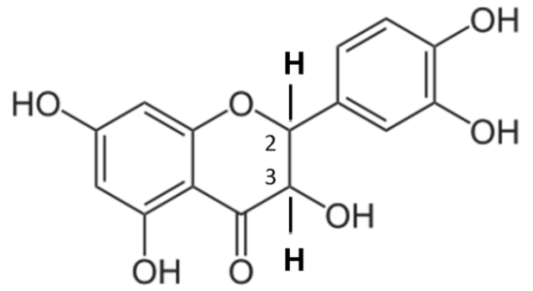

Four main functions of TAXIFOLIN are to neutralize free radicals, repair oxidized membranes, decrease reactive oxygen species production, and—via lipid metabolism, short-chain free fatty acids and cholesteryl esters—neutralize reactive oxygen species. The polyphenolic rings of TAXIFOLIN molecule can react and detoxify free radicals, it is also very stable. A robust body of science both at the clinical and mechanistic level show that antioxidant nutrient such as TAXIFOLIN is capable of neutralizing free radicals and limiting cell damage. This dietary polyphenolic compound has been shown to be effective in managing healthy levels of inflammation primarily because of its antioxidant activities.

**Cellular Anti-Inflammatory Assay (NFkB) TAXIFOLIN-RICH EXTRACT** / Test by Brunswick Laboratories, INC (USA) /

|  |  |  |  |  |  |
| --- | --- | --- | --- | --- | --- |
| **Results: Description** |  | **Analysis** | **Inducer/**  **Stressor** | **Maximum inhibition** **NFkB**  (%) | **Effective Concentration**  (μg/mL) |
| TAXIFOLIN rich extract “Et.Cosm.” |  | Cellular Anti-inflammatory Assay (NFkB) | TNF-alfa | **53.79** | 423.98 |

*Cellular Anti-Inflammatory Assay (NFkB) determines the anti-inflammatory potential of a given material in human cells. NFkB (Nuclear Factor kappa B), a protein complex that is involved in cellular responses to stimuli such as stress and free radicals, is used as inflammation biomarker. Such important protein is NF-κB which is implicated as a key transcription factor in the development of tumors, tumor metastasis, angiogenesis (an essential component for tumor growth), and chronic inflammation.*

*In this particular NFkB assay, Tumor necrosis factor alpha (TNF-alfa), a pleiotropic inflammatory cytokine, is introduced to the human cells to trigger cellular inflammation. If an anti-inflammatory material presents in the cellular environment, the material inhibits NFkB activation and the degree of inhibition can be monitored via NFkB expression. NFkB expression level of the human cells, treated with and without test materials, under the stressed condition are therefore monitored and compared. Maximum percentage of NFkB expression inhibition induced by tested materials is reported. The concentration used that induced the maximum inhibition of NFkB expression is also noted.*

Science indicates many health concerns boil down to basic bodily functions like inflammation, which can result in oxidative stress. TAXIFOLIN is a unique catalyzer that is shown to stimulate production of antioxidant enzymes inside cells, therefore protecting cells from free radical damage; and has been shown to help support basic body functions to reduce inflammation and oxidative stress while improving blood vessel health. TAXIFOLIN is effectively used by our body to perpetuate the glutathione recycling mechanism, the body’s way of continuing the antioxidant process. Its antioxidant benefits are fully preserved for bioavailability, and its ability to facilitate the glutathione pathway of antioxidant regeneration is strengthened. TAXIFOLIN is able to stimulate the activities of our antioxidant enzymes such as catalase and glutathione peroxidase. TAXIFOLIN plays a big role in maintaining the homeostasis of the oxidative balance. The truth is that both oxidation and silent inflammation can ravage our health and lead to serious maladies. Fortunately, there’s a great product that is scientifically validated to control both—natural TAXIFOLIN.

Therefore, nutritional antioxidants can decrease lipid and protein oxidation, potentially encouraging quicker recovery and protecting against deterioration to chronic inflammation and diseases.

Besides just knowing if TAXIFOLIN decreased the number of reactive species, we can better understand its true benefits by determining what pathways ingredient impacts. So, suppose a reactive species leads to an increase in atherosclerosis by increasing or decreasing pathways x, y, and z. In that case, one can get an idea of a product’s potential by measuring those pathways. Over time, we will learn what pathways to measure and how the body can absorb and deliver the antioxidant product to the desired tissue.

TAXIFOLIN has a regulating and modulating effect on key functional systems of cells, organs and tissues of the body, including: antioxidant system of cells and tissues; enzymatic systems, including representatives of almost all classes and groups of enzymes (oxido-reductase, hydrolase, lyase, transferase, kinase); receptor apparatus of cells and intracellular information systems; systems of ion transport and ionic homeostasis of the cell.

Some of our ideas pair TAXIFOLIN and resveratrol for instance to achieve NAD+ boost. The best decisson is upping the ante in the anti-aging arena with a liposomal supplement that claims to boost NAD+ (NAD+ the nicotinamide - coenzyme that helps other enzymes to work at the cellular level). NAD is crucial for everyday health but decreases with age and certain conditions.

As the average human lifespan increases, discoveries about cellular aging may provide keys to achieve beneficial effects across multiple health outcomes. Many hallmarks of aging occur within the cells, such as the accumulation of DNA mutations, the shortening of telomeres, the accumulation of protein aggregates, as well as changes to the epigenetic landscape of people’s genomes. However, it seems the accumulation is not a solely random process, and opportunities are available to influence its progress. This evidence comes from research in model organisms—from invertebrates such as nematode worms or fruit flies, all the way through to mammals, including rodents and primates—which has shown that mutations in single genes, or interventions that target these genes and their pathways, can extend lifespan significantly, and delay or prevent the onset of age-related conditions.

**Cellular Anti-aging Assay (SIRT1) TAXIFOLIN-RICH EXTRACT** / Test by Brunswick Laboratories, INC (USA) /

|  |  |  |  |  |  |  |
| --- | --- | --- | --- | --- | --- | --- |
| **Results: Description** |  | **Analysis** | **Marker** | **Maximum SIRT1 Expression Change (%)** | **Effective Concentration Taxifolin** | **Units** |
| TAXIFOLIN rich extract “Et.Cosm.” |  | Cellular Anti-aging Assay | SIRT1 | **30.4** | 14.8 | μg/mL |

*Cellular Anti-aging Assay (SIRT1) measures the anti-aging ability of a material using SIRT1 production in human cells as a biomarker for anti-aging. SIRT1 is a protein that is believed to play important roles in longevity and reduction of age-related diseases.*

*Previous studies have shown that when mammals age, SIRT1 expression decreases, where induction and activation of SIRT1 has been associated with extended lifespan. These studies have triggered the search for SIRT1 activators that may be used as functional agents to promote health and longevity.*

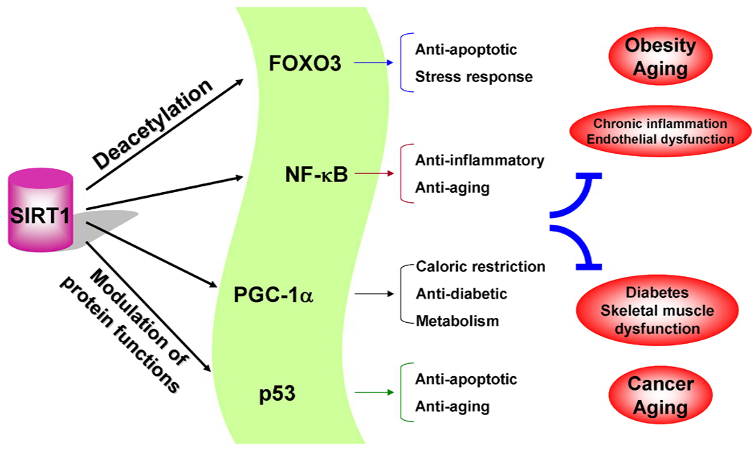

The prevalence of genes involved in pathways related to nutrients and energy demonstrates it is not just important which nutrients people put into their bodies, but also how these nutrients are sensed and metabolized in the cells. This suggests promise exists in taking the target genes and treatments identified and applying them to the development of interventions that support healthier human aging.

In the redox regulation of cell transcription, TAXIFOLIN supports the protective effect of enzymes of the enzymatic link of the antioxidant system of the cell, in particular, enzymes of the first line of antioxidant defense (peroxidases, catalases, etc.). The ingredient has an indirect antioxidant effect, capable of activating (or stimulating) phase 2 detoxification enzymes in the liver, which act as a defense mechanism, triggering a wide range of antioxidant processes, preventing cell damage. The indirect antioxidant effect of TAXIFOLIN persists even after its elimination from the body, in contrast to the direct antioxidant effect of the ingredient.

**Cells viability ATP method TAXIFOLIN-RICH EXTRACT** / Test by Brunswick Laboratories, INC (USA) /

|  |  |  |  |  |
| --- | --- | --- | --- | --- |
| **Results: Description** |  | **Test** | **Result** | **Units** |
|  |  |  |  |  |
| TAXIFOLIN rich extract Et.Cosm. |  | Viability | 990.31 | μg/mL |

*Cells viability ATP method. The adenosine triphosphate (ATP) luminescence assay is a highly effective method for the quantitative evaluation of proliferation and cytotoxicity of cultured human cells. ATP is a marker for cell viability because it is present in all metabolically active cells and the concentration declines rapidly when the cells undergo necrosis or apoptosis.*

*The viability result is expressed as the sample concentration which the number of viable cells in culture based on quantitation of the ATP present is the maximum.*

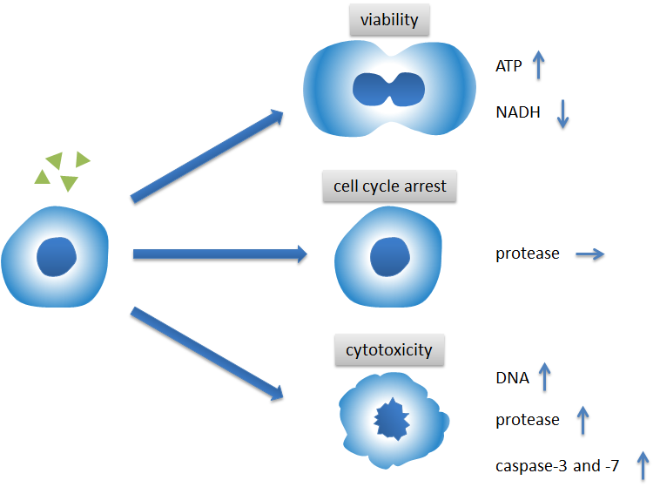

*The amount of ATP in cells correlates with cell viability. Within minutes after a loss of membrane integrity, cells lose the ability to synthesize ATP, and endogenous ATPases destroy any remaining ATP; thus the levels of ATP fall precipitously.*

TAXIFOLIN like relative compounds enhance the role of vitamin C and are the most abundant source of antioxidants in our diets. Anthocyanins are the primary active forms found in fresh berries such as blueberries, blackberries, raspberries and strawberries. These compounds also play important roles as immune enhancers, in anti-inflammatory activity, cardiovascular support and many other health functions. The best idea is to use the synergy effects of TAXIFOLIN with such compounds that is to make another step in bringing a more complete spectrum of nature’s ingredients into one product. There is the scientific evidence of the synergy between TAXIFOLIN and Vitamin C, where both support each other inside the body.

|  |  |
| --- | --- |
| **Summary table Efficacy cellular system of**  **TAXIFOLIN-RICH EXTRACT 92% purity assay**  **(manufacture "Etalon Cosmetics", Russian Federation)** | |
| **Total ORACFN** | 66 946 μmole TE/gram |
| **CAA** (Cellular Antioxidant Assay) | 437.77 μmole QE/gram |
| **EC50** (less means more active) | 61.17 µg/mL |
| **Cellular Anti-Inflammatory Assay (NFkB)** determines the anti-inflammatory potential of a given material in human cells. NFkB (Nuclear Factor kappa B), a protein complex that is involved in cellular responses to stimuli such as stress and free radicals, is used as inflammation biomarker. | Maximum inhibition - 53.79%  Effective Concentration –  423.98 µg/mL |
| **Cellular Anti-aging Assay** (SIRT1) determines the impact of a test material on expression/production level of SIRT1 in human cells. SIRT1 serves as an anti-aging biomarker. | Maximum SIRT1 Expression Change (%) 30.4  Effective Concentration  14.8 µg/mL |
| **Cells viability ATP method.** The adenosine triphosphate (ATP) luminescence assay is a highly effective method for the quantitative evaluation of proliferation and cytotoxicity of cultured human cells. | Sample concentration corresponds to ATP present is the maximum.  990.31 μg/mL |

**Genes Carry Instructions that Tell Our Bodies How to Work.** Genes play a critical role in the development of the brain and in our health. How nutrients can normalize those expression profiles with nutrients, i.e., how we can normalize the changed gene expression profiles in various states of organism or life stages to a more normal expression profile using targeted nutrients.

Ability to keep ageing at bay: TAXIFOLIN-RICH EXTRACT is able to switch a specific category of genes back on that not only made cells look youthful, but start to behave more like young cells and start dividing. The discovery how TAXIFOLIN performs the work could well contribute to a healthier ageing approach, in which degenerative effects associated with getting old could be alleviated.

TAXIFOLIN can inhibit cellular inflammation through the activation of PPARg and AMPK (Adenosine Monophosphate activated Protein Kinase), an upstream activator of the anti-inflammatory gene transcription factors SIRT1 (Sirtuin 1) (see test results above with TAXIFOLIN-RICH EXTRACT).

According the studies the versatile thing is that the sixty-five genes, including a few detoxification enzymes (NQO1, GSTM1) and an antioxidant enzyme (TXNRD1), were up-regulated and 363 genes were down-regulated in the presence of TAXIFOLIN. In view of the finding that selected genes contained antioxidant response element (ARE), it was stressed that TAXIFOLIN modulates chemopreventive genes through activation of the ARE. Transient transfection experiments using the ARE QR-CAT construct demonstrate that TAXIFOLIN significantly activates ARE, but not xenobiotic response element (XRE). Thus, TAXIFOLIN acts as a potential chemopreventive agent by regulating genes via an ARE-dependent mechanism.

The expression of genes encoding antioxidative and Phase II detoxification enzymes is induced in cells exposed to electrophilic compounds and phenolic antioxidants. Induction of these enzymes is regulated at the transcriptional level and is mediated by a specific enhancer, the antioxidant response element or ARE, found in the promoter of the enzyme's gene. The transcription factor Nrf2 has been implicated as the central protein that interacts with the ARE to activate gene transcription constitutively or in response to an oxidative stress signal. Recent studies suggest that the sequence context of the ARE, the nature of the chemical inducers, and the cell type are important for determining the activity of the enhancer in a particular gene.

We are taking exciting steps to understand the core mechanisms of actions of our ingredient. This is a monumental step in understanding the cellular processes behind the breadth of benefits this TAXIFOLIN offer.

**Feedback from experts**:

“I also hope through this great project we help to improve and discover a great nutritional product for the mankind - I hope we all celebrate together when that is achieved.” *Jin Ji, PhD, MA/Management, CTO & EVP, Brunswick Laboratories, Inc.*

“I also really hope that we will participate to the improvement and the discovery of a fantastic nutritional product for the mankind and that we'll celbrate this together.” - Lecturer at the Lorraine University- fundaments of Biology, Bioethics and evolution, - *Co-founder and General Secretary of the "International Society on Chocolate and Cocoa in Medicine (ISCHOM)", - Member of the "Société Française et Francophone des Plaies et Cicatrisation" ("French and Francophone Society of Wounds and Healing"), - Member of the "Société Française de Génie Biologique et Médical" ("French Society of Biological and Medical Engineering"), - Member of the "Société Française de Statistiques" ("French Society of Statistics"), - Member of the "Société Française du Cancer" ("French Society of Cancer"), - Member of the "European Association for Cancer Research (EACR)", - Member of the "European Wound Management Association (EWMA)", - Member of the "International Society of Nutraceuticals & Functional Foods (ISNFF)", - Independent expert of the "Syndicat National des Compléments Alimentaires" ("National Trade Union of Nutritional Supplements") involved in the working group "Quality-Regulation-Nutrivigilance/Toxicology. Dr. Jean-François BISSON – Laboratory ETAP, Nancy, France.*

Recently, we have seen health consciousness increase greatly during the pandemic. This has caused consumers to spend more time researching natural, evidence-based and safe products to meet their health needs. This would ultimately encourage a proactive, preventive approach to maintaining health and immunity during these turbulent times.

TAXIFOLIN creating biologic therapies for immune modulated diseases and disorders such as metabolic diseases, brain disorders, inflammatory disorders, skin health, and immune wellness.

Consumers continue to be at risk of adulterated ingredients. This could create major difficulties for an industry reliant on consumer trust as well as to meet industry-specific quality assurance standards. Quality means connecting all of the dots between communications and transparency in sourcing and processing, stewardship and sustainability practices, scientific rigor, testing and compliance. Manufacture "Rokiškio pragiedruliai", (Lithuania, EU) pays considerable attention to the qualifications of its raw material suppliers, as well as strict adherence to the process parameters in the production of TAXIFOLIN.

With the same 2R3R - Taxifolin content in the “commercial product Taxifolin” of several manufacturers, the ORAC value is different, which indicates the lack of technological solutions used by manufacturers to isolate the native form of Taxifolin. In view of the significant tendency of Taxifolin to form polymeric forms with less biological activity, additional methods are regularly used to determine the composition of the monomeric part of optically active Taxifolin, by matching another maximum absorption spectrum of the molecule at the UV absorption band of 340 nm, namely the absorption by the monomeric part that is not polymerized. , not associated with saponins, other compounds of larch oleoresin - "the commercial product Taxifolin". In aqueous solutions, the UV absorption band at 328-340 nm belongs only to the monomeric form of Taxifolin, and the band at 290 nm belongs to the monomeric and polymeric (the ratio of which changes after filtration), thus allowing to find the amount of low and high molecular weight polymers in the "commercial product Taxifolin" when using additional techniques. The presence of polymer forms is undesirable for two reasons: it is an extra ballast and it is a sorbent capable of lowering the effective concentration of the more active monomeric form of Taxifolin and other active substances when used as part of dietary supplements. Polymerization of Taxifolin is carried out by covalent bonding through phenolic hydroxyl groups.

The optic active enantiomerically pure native molecule form of TAXIFOLIN presumes its monomer form by excluding epimerization – isomerisation – polymerisation sequences.

Health claims

**ANTIOXIDANT** - Support for overall health - Helps prevent cellular damage from free radical stress. Can decrease lipid and protein oxidation, potentially encouraging quicker recovery and protecting against deterioration to chronic inflammation and diseases.

**ANTI-INFLAMMATORY** - The inflammation response in the body ideally works acutely and efficiently to solve injury and infection threats to health, then resolves back to homeostasis. For many reasons, however, prolonged or increased inflammation can persist into a chronic state leading to poor health and debilitating disease. The size and growth of the anti-inflammatory therapeutics market provides a high-level view of the importance of inflammation management to consumers.

**ANTI-AGEING** - helps slow the aging process, reduce age-related cognitive decline, and prevent cellular damage from free radicals. Helps Repair, Rejuvenate and Defy Aging.

**CARDIO-VASCULAR HEALTH** - Join us for a deep dive into heart health and how TAXIFOLIN, an ingredient backed by 60+ years of science, can help you meet the needs of today’s consumers.

**Prevention and support - METABOLIC SYNDROME** - the most common pathological condition leading to serious chronic diseases.

Can be used to **SUPPORT GENERAL IMMUNITY** - TAXIFOLIN’s ability to support innate immunity; TAXIFOLIN’s capacity to strengthen adaptive immunity; TAXIFOLIN’s impact on inflammation and oxidative stress.

**GUT HEALTH** with TAXIFOLIN - Whether we’re aware of it or not, for centuries the gut has been far more than a functional part of the anatomy. It has been a cornerstone of a safe and healthy life. Now, good gut health has risen to the top of the agenda.

**COGNITIVE ENHANCEMENT** - reduce decline in age-related cognitive health, promote the brain’s healthy neuronal function, helps supports a calm mind. Flavonoid-rich diet linked to lower Alzheimer's risk, says large-scale study: Older adults who consumed large amounts of flavonoid-rich foods were two to four times less likely to develop Alzheimer's disease and related dementias over 20 years compared with people whose intake was low, in a study of 2,800 people.

**SPORTS NUTRITION** - rehabilitation after physical exertion is extremely important so as not to reveal the redox balance. At the same time, taking Taxifolin before exercise promotes greater endurance. Taxifolin according to the study of specialized accredited laboratories is not doping. As the market for sports nutrition products transitions from one specifically targeting high-performance and professional athletes to one aiming at “active” consumers, the effort to find innovative ingredients and product offerings has picked up.

TAXIFOLIN will seek the game changers, disruptors and pioneers who are unlocking innovation in the Nutrition and Cosmetic development industries. Our expertise gives manufacturers an edge in making products that address a complex set of consumer demands, such as label-friendly, plant-based and other "free-from" formulation challenges. Sitting at the crux of reformulation and innovation, it represents the way "Etalon Cosmetics" with its TAXIFOLIN helps our customers succeed.

*Taxifolin (syn. Dihydroquercetin) is approved in USA for the use in dietary supplements according Dietary Supplement Health and Education Act of 1994 as well as in cosmetics and hygiene products.*

*TAXIFOLIN-RICH EXTRACT was studied by the EFSA (European Food Safety Agency) NDA Panel (EFSA Panel on Dietetic Products, Nutrition and Allergies). Panel concludes that taxifolin-rich extract from Dahurian Larch, is safe under the proposed conditions of use. (EFSA Journal 2017;15(2):4682).*

*COMMISSION IMPLEMENTING REGULATION (EU) 2017/2470 of 20 December 2017 establishing the Union list of novel foods in accordance with Regulation (EU) 2015/2283 of the European Parliament and of the Council on novel foods: TAXIFOLIN-RICH EXTRACT - Specified food category - Food Supplements as defined in Directive 2002/46/EC intended for the general population, excluding infants, young children, children and adolescents younger than 14 years. Maximum levels: 100 mg/day. (L 351/72 Official Journal of the European Union 30.12.2017).*

*COMMISSION IMPLEMENTING REGULATION (EU) 2018/461 of 20 March 2018 authorising an extension of use of taxifolin-rich extract as a novel food under Regulation (EU) 2015/2283 of the European Parliament and of the Council, and amending Commission Implementing Regulation (EU) 2017/2470. (L 78/7 Official Journal of the European Union 21.3.2018)*